**第一大题：**

1. **建表：**

建表使用的DDL语句如下：

①由于area_table的store_id带有唯一性，因此设置store_id为主键。

create table area_table(

store_id varchar(10) PRIMARY key,

area varchar(20),

leader_id int

);

②由于store_table的store_id是关联area_table表的，里面的数据是受主表约束的，因此需要外键store_id去作为约束。

create table store_table(

store_id varchar(10),

order_id varchar(12),

sales_volume int,

salesdata date,

CONSTRAINT store_table1 FOREIGN KEY(store_id)REFERENCES area_table1(store_id)

);

③导入数据，运用到的DML语句如下（备注：仅列举插入其中两条语句为例）：

Insert into area_table values('store1','alpha',139844);

....

Insert into store_table values('store8','000089948724',499,'2022-03-23');

.....

1. **统计**
   1. 运用到的DQL语句如下：

SELECT

salesdate AS '日期',

store_id,

sum( sales_volume ) AS '店铺销量'

FROM

store_table

GROUP BY

store_id,

Salesdate

结果：

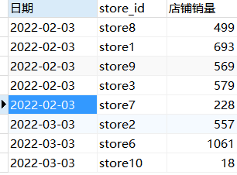

* 1. 运用到的DQL语句如下：

SELECT

salesdate AS '日期',

area AS '区域',

sum( sales_volume ) AS '店铺销量'

FROM

( SELECT a.salesdate,b.area,a.sales_volume FROM store_table a LEFT JOIN area_table b ON a.store_id = b.store_id ) all_table

GROUP BY

area,

salesdate

ORDER BY

Salesdate

运行结果如下：

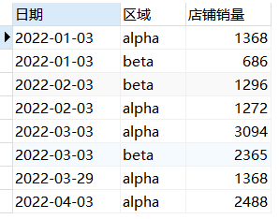

1. **程序异常**

3.1、运用左外连接的查询方式，查询的时候时间已经有明确的条件将昨天销量为0的store3给过滤筛选掉了，导致无法显示store 3的结果。

3.2、无法给出正确的查询条件。

**第二大题：**

1. WITH temp_active_hour_table_kps AS ()

8. UNION ALL

SELECT

dt,

product_id,

mkey,

min( HOUR ) AS HOUR,

device_id,

'first' AS STATUS

FROM

temp_active_hour_table_kps

GROUP BY

dt,

mkey,

product_id,

device_id

10.LEFT JOIN

( SELECT dt, device_id FROM kps_dwd.kps_dwd_dd_fact_view_new_user WHERE dt = '${dt_1}' GROUP BY dt, device_id ) b ON a.dt = b.dt

AND a.device_id = b.device_id

12.LEFT JOIN

asian_channel.dict_lcmas_channel b1 ON a1.mkey = b1.mkey;